The Mussels That Came in from the Cold: long-term effects of the population collapse in the 1960s may explain why boreal mussels in the subarctic did not benefit from warming
Julia T. Marchenko^{1*}, Vadim M. Khaitov^{1, 2}, Larisa A. Basova³, Evgeny A. Genelt-Yanovskiy⁴, Sergey S. Malavenda⁵, Petr P. Strelkov^{1, 5}
¹Faculty of Biology, St. Petersburg State University, St. Petersburg, Russia
²Kandalaksha State Nature Reserve, Kandalaksha, Russia
³Algology Laboratory, Murmansk Marine Biological Institute of the Russian Academy of Sciences, Murmansk, Russia
⁴ Department of Earth and Environmental Sciences, University of Exeter, Penryn Campus TR10 9FE, UK
⁵ Natural Science and Technologies Institute, Murmansk Arctic University, Murmansk, Russia
Keywords: transient population dynamics, Arctic warming, Mytilus trossulus, M. edulis, demography, long-term observations, Allee effect

Summary
Boreal blue mussels were the heralds of climate warming in the Arctic, appearing in Spitsbergen a quarter of a century ago after the absence of a millennium. Here we tested the hypothesis that warming has a beneficial effect on subarctic mussels, too. We analysed two datasets from the Murman Coast, 1000 km southeast of Spitsbergen across the Barents Sea. Demographic analysis of the population monitored in 2001-2020 showed that temperature had a positive effect on recruitment and survival. However, no positive effect was found in the analysis of the mussel biomass dynamics in 1933-2020. The abundance was high until the 1960s and then dropped tenfold. The collapse coincided with the climate cooling. The populations partially recovered in the subsequent, unprecedentedly warm period, but no direct relationship between the recovery and temperature was found. We speculate that the subarctic mussels could not benefit from the warming due to long-term consequences of the collapse. The Allee effect in their depleted populations might have limited recovery for decades. Besides, the fitness of blue mussel populations is currently undermined by competition and hybridization between the two cryptic species, the aboriginal Mytilus edulis and the invasive M. trossulus, which presumably naturalized after the collapse.
Introduction
Boreal species at the northern limit of their distribution generally benefit from climate warming, the benefits being expressed in their increasing abundances and expanding ranges (Parmesan, 2006; Poloczanska et al., 2016). In the Arctic Ocean these processes are part of the ecosystem regime shift referred to as Atlantification and borealization (Fossheim et al., 2015; Polyakov et al., 2020; Csapó et al., 2021; Ingvaldsen et al., 2021). Boreal blue mussels Mytilus are considered as beneficiaries of climate warming and the heralds of borealization in the Arctic (Berge et al., 2005; Leopold et al., 2019; Csapó et al., 2021).
Two species of blue mussels, M. edulis and M. trossulus, are ubiquitous in boreal and subarctic seas (Gosling, 2021). Being cryptic species, they are usually not distinguished in ecological studies (Katolikova et al., 2016). Blue mussels are powerful ecosystem engineers in coastal ecosystems, important aquaculture objects (Seed, Suchanek, 1992; www.fao.org) and stratigraphically significant organisms. The presence of subfossil Mytilus shells in the Quaternary sediments is a reliable marker of boreal conditions in the Arctic, as shown for the Kara Sea (Troitsky, 1966), Northern Greenland (Dyke et al., 1996) and Novaya Zemlya (Mangerud et al., 2008). In Spitsbergen blue mussels appeared and disappeared throughout the Late Pleistocene-Holocene in accordance with climate fluctuations (Blake, 2006; Hansen et al., 2011; Mangerud, Svendsen, 2018). The current warming was marked by a new invasion in the early aughts (Berge et al., 2005), so that the researchers could observe this striking event just as it was unfolding.
It would be reasonable to assume that mussel abundance should be positively correlated with water temperature not only in the high Arctic but also in the subarctic (sensu Dunbar, 1953), e.g., in the southern Barents Sea, where mussels, as far as it is known, have always been present (Zenkevich, 1963). It also stands to reason that these dynamics should be evident on time scales shorter than millennia. Unfortunately, these assumptions cannot be reliably tested due to the paucity of data on subarctic mussels. To our knowledge, only two studies, both based on limited data, have addressed mussel dynamics on the decadal time scale at these latitudes (Feder et al., 2003; Marchenko et al., 2023), and no obvious link between mussel abundance and water temperature has been found in either of them. In contrast, the data on mussels from the temperate seas are extensive. They generally indicate a decline in abundance in recent decades (Jones et al., 2010; Sorte et al., 2017; Seuront et al., 2019; Baden et al., 2021), which is consistent with the idea that warming should have a negative impact on the species in the ‘warmer’ part of its range (Parmesan, 2006).
The Murman Coast, where our study was carried out, lies in the southwest of the Barents Sea, about 1000 km southeast of Spitsbergen (Fig. 1). Even before the acceleration of the climate warming in recent decades, the thermal state of the Barents Sea has been unstable at the interannual and the decadal time scale, mainly due to variability in the inflow of warm Atlantic water (Levitus et al., 2009). These variations have been monitored at the Kola Section, with the oceanographic data from the 0-200 m water layer at stations 3-7 (Fig. 1) being available since 1900 (Karsakov et al., 2022). These data are believed to be a reliable representation of the thermal dynamics of the entire Barents Sea (Fossheim et al., 2015; Dalpadado et al., 2020). Throughout the observation time, the coldest periods were 1900-1920s and 1960s-1980s, while the warmest periods were the very last decades (Boitsov et al., 2009; Karsakov et al., 2022).
The entire ecosystem of the Barents Sea has been changing alongside with the climate (Loeng, Drinkwater, 2007; Matishov et al., 2012; Ingvaldsen et al., 2021; Pedersen et al., 2021). The general trend in the abundance of boreal species in 1950-2013 is U-shaped, with low values during the coldest period in the 1960s-1980s (Pedersen et al., 2021). This trend is consistent with the data on fluctuations of the water temperature and correlated factors including primary production (Dalpadado et al., 2020). The available limited data for the first half of the 20th century also indicate that boreal species thrived during warm periods (Nesis, 1960; Loeng, Drinkwater, 2007 and references therein).
The Murman Coast is the northeasternmost edge of the Atlantic littoral communities and the only area of the Arctic Ocean which is usually free of ice throughout the year (Zenkevich, 1963). For a long time the mussels in the Barents Sea were thought to be M. edulis but both M. edulis and M. trossulus were identified in genetic studies, the latter probably invading with maritime traffic in the 20th century (Väinölä, Strelkov, 2011). Mussels are not fished or farmed at the Murman Coast (Marchenko et al., 2023), and their dynamics there can be considered as natural.
Despite a long history of quantitative studies at the Murman littoral (Zatzepin et al., 1948), including focused studies of mussels (e.g. Matveeva, 1948; Antipova et al., 1984; Strelkov et al., 2001), data on the long-term dynamics have never been summarized for any of the littoral species. We only know that the abundance of mussels declined dramatically along the entire coast in the 1960s (Antipova et al., 1984; Marchenko et al., 2022). This population collapse coincided with the start of the cold period (1960-1980) and was explained by the negative impact of the cooling (Antipova et al., 1984). This explanation seemed obvious, especially considering that the abundance of many other boreal species, including benthic ones, decreased in the Barents Sea at that time (Antipova, 1975; see also above). However, in 2009 we re-studied the mussel populations at the three ‘historical’ sites and found that they had not recovered from the decline, even though the mean annual water temperatures in the Barents Sea had already exceeded the historical maximum by that time (Marchenko et al., 2023). This unexpected observation was one of the stimuli for the present study.
Our overall aim was to elucidate the patterns and drivers of the dynamics of subarctic mussels on the decadal scale using evidence from the mussel populations of the Murman Coast. To achieve this aim, we tested two working hypotheses. Firstly, we summarized the available data on mussel abundance and correlated it through time with water temperature at the Kola Section. We expected a positive relationship between abundance and temperature and a U-shaped pattern of abundance in 1930s-2020s. Secondly, we determined the age structure of mussels in samples from the population monitored almost annually in 2001-2020, evaluated the success of different year-of-birth cohorts and correlated it with water temperature and other meteorological data from the nearest weather station. Using these data, we tested the hypothesis that mussels showed a more successful recruitment and/or survival in warm years than in cold ones.
Materials and Methods
Primary data and the workflow of the analysis
Analysis of long-term dynamics
As a measure of mussel abundance, we used mean biomass, kg/m², calculated from samples collected on vertical transects across the littoral at sites with known coordinates. Mussels from the same site are referred to in our study as a population. We used transect data because mussels are not uniformly distributed across the littoral and single or non-random estimates may be biased. We used biomass rather than density because biomass is less sensitive to the accuracy of counting small mussels and because historical studies usually report biomass.
Two data sources were used. (1) All the data available in the literature. We used the catalogues of the libraries of the Russian Academy of Sciences, the Kandalaksha State Nature Reserve and the St. Petersburg State University to search for sources published before 2005 and Google Scholar with the keywords “Mytilus” and “Kola Bay” or “Barents Sea” for the recent ones. (2) Our own data, mostly collected at the historical study sites: 43 estimates from nine sites obtained in 2001-2020 (Fig. 1, Table S1). Samples, 3-5 per transect, were taken using a core of 0.01-0.1 m² (the core area depended on the abundance of mussels) and washed through a 1.0 mm sieve. Biomass was determined either by weighing samples to the nearest 1 g or predicted from lengths of individual molluscs using the formula developed for the mussels at the Murman Coast (Kostylev, 1989). The details of sample collection and processing are provided in Table S1.
The general structure of the historical data was known in advance. Several biological research stations operated along the coast at different time periods (Fig. 1). Populations in their vicinity have been studied best and, at some sites, repeatedly (e.g. Strelkov et al., 2001; Marchenko et al., 2023). The populations studied in at least three different decades are referred to as monitoring ones. The Research Institute of Fisheries and Oceanography (VNIRO) conducted cruises to monitor mussel abundance along the coast in 1960-1961 (Romanova, 1969), in 1971 and 1981 (Antipova et al., 1984), and in 2002-2005 (Milyutin, Sokolov, 2006), and during these cruises many sites were sampled in the same season or several consecutive ones (Fig. 1).
In the data used in our study, different time periods were characterized by widely different numbers of biomass estimates, sometimes obtained at weakly overlapping sets of sites (see Results). For this reason, we chose to analyse them in a piecemeal fashion rather than as a whole. The following analyses were performed.
Firstly, we compared the patterns of biomass distribution along the coast in VNIRO surveys of different years (Model 1). In this way, we could take into account the heterogeneity of environmental conditions along the coast, in particular, the temperature gradient: the mean annual water surface temperature in the east is about 1.5 °C lower than in the west (Terziev et al., 1990). Since the coast extends longitudinally, the differences in longitude between the survey sites were used as a proxy of the distance between them.
Secondly, we used the data from the best studied areas to reconstruct mussel dynamics there (Model 2). Finally, we correlated the data from monitoring populations with water temperature. Data for two time intervals were analysed: 1930s-1970s and 1980s-2010s (Model 3). The first interval covered the period from the beginning of observations to the collapse of the populations (Antipova et al 1984; see also Results), while the second one covered all the subsequent years. The mean annual water temperatures in the 0-200 m layer at stations 3-7 of the Kola Section (Bochkov, 2005; Karsakov et al., 2022; http://pinro.vniro.ru/ru/) averaged over the five years preceding the year of the mussel survey were used. The 5-year period was chosen because local littoral populations are dominated by mussels under 6 years of age (Marchenko et al., 2023).
Demographic analysis
Data from the YaL population (Fig. 1C) sampled in 2001-2007, 2009-2013, 2016-2018, and 2020 were used. The age of all mussels in the samples or, if mussels in the samples were very numerous, in random subsamples from the samples (see Table S1), was assessed by counting marks of winter growth delay on shells as in Sukhotin et al. (2007). Numbers of mussels of individual age-of-birth cohorts (hereafter, generations) per m² in different years were estimated.
Only generations born after 1998 and recorded in samples from at least four different years at an age older than one year were included in the analysis. Estimates of abundance in four different years were arbitrarily accepted as minimally sufficient to reconstruct the survivorship curve for a cohort. One-year-old mussels were ignored because their length could be less than 1 mm, which was the size of the mesh of the sieve used in our study.
We assumed that, since mussels are organisms with survivorship curve Type III (Deevey, 1947), their numbers per m² in individual generations should decline exponentially with time. This was indeed observed (see Results). Variations of logarithmic values of numbers of individual generations between years were approximated by the linear model. The slope of the regression (z) was considered as a proxy of the generation death rate per year while the intercept term (N₀) was considered as a proxy of its recruitment success. For further analyses, each generation was characterized by the set of demographic parameters: N₀, z and logarithmic values of mussel abundance at ages 2-10 (N₂-N₁₀), where missing empirical values were predicted from the model fitted. Mussels older than 10 years were extremely rare in our collections and therefore were ignored.
We set out to determine which environmental parameters available from the nearest weather station (Teriberka, WMO no. 22028, 40 km west from YaL, Fig. 1) at http://portal.esimo.ru/ best explained the variation of demographic parameters between generations. The environmental parameters included air and sea surface temperatures, wave height, wind speed above water surface averaged over each of the four seasons of the year of generation birth, and air and sea surface temperatures averaged over each of the four seasons over the period from the year of generation birth to the year when it was recorded in our collections for the last time (data in Table S2). The seasons for the Barents Sea were defined following Terziev et al. (1990): winter in November-April (i.e. including the last two months of the previous year), spring in May-June, summer in July-August and autumn in September-October.
The workflow of the statistical analysis was as follows. Firstly, we identified the subset of environmental parameters that best explained the variation of demographic parameters between generations using the BIO-ENV procedure (Clarke, Ainsvorth, 1993). It is based on comparing the biotic (in our case, demographic) similarity matrix with the equivalent matrices for all combinations of environmental parameters and selecting the subset of environmental parameters providing the best match between the two configurations. Secondly, we visualized and statistically evaluated the associations between demographic parameters using the same similarity matrix as in the first analysis and environmental parameters selected by BIO-ENV with the help of redundancy analysis (RDA, van den Wollenberg, 1977).
Statistical modelling
The statistical analyses were carried out using the R statistical programming language (R Core Team, 2025). Functions from the package "mgcv" (Wood, 2011) were used for analyses of the long-term mussel dynamics, and functions from the package "vegan" (Oksanen et al., 2020) were used for the demographic analysis (BIO-ENV, RDA).
Analysis of long-term dynamics
Boreal Generalized additive (mixed) models (GA(M)M, normal distribution) with biomass after Box-Cox transformation (λ = 0.22) as a dependent variable were constructed. The validity of each model was checked by visual analysis of residual plots. Three regression models were fitted.
Model 1: Biomass as a function of longitude in VNIRO surveys. GAM with Longitude (continuous predictor) and Survey (discrete predictor with four levels) was fitted. The smoothers for each Survey were fitted separately.
Model 2: Biomass as a function of the year of survey in the best studied areas. GAMM with Year (continuous predictor) and Area (discrete predictor with three levels) was fitted. Site was included as a random factor. The smoothers for each Area were fitted separately.
Model 3: Biomass in monitoring populations as a function of water temperature in two time periods, 1930s-1970s and 1980s-2010s. GAMM with Temperature (continuous predictor) and Period (discrete predictor with two levels) was fitted. Site was included as a random factor. The smoothers for each Period were fitted separately.
Demographic analysis
In the BIO-ENV procedure the demographic matrix with rows corresponding to years of generation birth and demographic parameters as columns was transformed into a matrix of Euclidean distances between years. This matrix was compared using Mantel correlation with 16 777 215 matrices of Euclidean distances between years, derived from all possible subsets of 24 environmental parameters.
The statistical significance of the RDA model, individual canonical axes and environmental constraints was assessed by permutation methods (Borcard et al., 2011), with 9 999 permutations being set up.
Results
Long-term dynamics
In total, we obtained 173 estimates of mean biomass at 62 sites from 1933-2020 (Table S3). The most abundant data were obtained in the 1960s, while data for the 1940s and the 1990s are completely missing (Table 1). The most intensive surveys were conducted in the outer Kola Bay and its vicinity, in Dalnie Zelentsy area and in the Seven Islands Archipelago area (Table 1; Fig. 1), with twelve populations from these areas studied in at least three different decades. They are referred to as monitoring populations (Fig. 1; Table S3).
A general idea of the main patterns of spatial and temporal dynamics of mussels at the Murman Coast can be derived from Fig. 2, where biomasses obtained in different decades and during different VNIRO surveys are shown as a function of longitude. Two trends are noteworthy. Firstly, biomass tended to decrease with longitude in the data-rich 1960s. Secondly, the overall decrease in biomass after the 1960s can be seen. Both trends are confirmed by statistical analysis of VNIRO data. The fitted GAM confirmed a negative dependence of biomass on longitude in the 1960-1961 survey, with a dozen kilograms per m² in the west of the coast to a few kilograms in the east. It also confirmed that the biomasses in the 1960-1961 survey were higher than in all subsequent ones. In 1971, 1981 and 2002-2005 surveys biomasses were comparably low, on average less than 1 kg, and did not correlate with longitude (Model 1, Table S4; Fig. 2).
The pattern of temporal dynamics of biomass in populations from the three best studied areas throughout the entire observation period was similar and could be characterized as L-shaped rather than U-shaped. The maximum values were observed closer to the beginning of observations in the 1930s-1960s, while the minimum values were observed in the 1970s-1990s; in comparison, the values in the 21st century were medium-low (Fig. 3A). It should be noted that the biomass was also low in the early 1930s and the late 1950s (Fig. 3A), but the data for these periods are scarce and appear to be insufficient for conclusions.
The fitted GAMM confirmed that the curvilinear pattern of dynamics was similar in all the areas; it also confirmed that the biomass in the Seven Islands Archipelago area was generally lower than in the other areas (Model 2; Table S4).
Annual water temperature variation throughout the observation period was an inverted image of that of the biomass: the first decades of the 21st century were extremely warm, the 1970-1990 were the coldest, and the 1930-1960 were relatively warm (Fig. 3B). To remind, the decrease in abundance of the mussels between the early 1960s and the early 1970s was considered as a consequence of the Barents Sea cooling (Antipova et al., 1984; see Introduction). This cooling lasted for about 30 years and was followed by the greatest warming in the recorded history. However, this warming did not seem to lead to a full recovery of the mussel populations (compare Fig. 3A and Fig. 3B).
The relationship between the biomass of mussels in the monitoring populations and water temperature averaged over the five years preceding the year of the survey can be derived from Fig. 4. Visual inspection of the primary data (Fig. 4A) shows that (a) in all the cases the maximum biomass was observed in the 20th century, mostly in the 1930s or the 1960s, (b) in all the cases except one (population Ve) there was a trend toward a positive relationship between biomass and temperature in the 20th century, due to the differences between biomass estimates made during periods with contrasting temperature before and after the early 1960s, and (c) this relationship became blurred after the addition of the data from the 21st century. In particular, no trend was observed in the best studied YaL population in 1970-2020.
These trends were confirmed by GAMM. There was a strong positive relationship between the biomass and water temperature in the 1930s-1970s; after that, the relationship, though positive, was weak and insignificant (Fig. 4B; Model 3, Table S4). Throughout the observation period, the relationship was dome-shaped, with the maximum expected biomass values at temperature around 4.4 °C, which is close to the long-term average of 4.15 °C (Fig. 4B).
Demographic analysis
Sixteen generations born between 1999 and 2014 met data completeness requirements and were included in the analysis. Logarithmic values of numbers of individual generations generally decreased with age in a linear manner (Fig. S1; Table S5; Fig. 5B), and so it was possible to consider the slope of the linear regression (z) as a proxy of the generation death rate per year and the intercept term (N₀) as a proxy of its abundance at start, the i.e. recruitment success. There was (1) a strong positive correlation between N₀ and numbers of younger mussels (N₂-N₄) within generations as well as (2) a strong negative correlation of N₀ and z between generations (Fig. S2, see also below), indicating that mortality was density-dependent.
The results of BIO-ENV are illustrated in terms of RDA (Fig. 5C); full results are provided in Table S6. The first two canonical axes (RDA1, RDA2) were statistically significant (p<0.05), and so was the model as a whole (Table S7). Out of the five environmental parameters identified by BIO-ENV as best explaining the variation between generations, the wind speed and surface water temperature in spring of the year of birth and summer surface water temperature averaged over the lifespan significantly affected the ordination while the effects of air temperature in summer and air temperature in spring of the year of birth were marginally significant (0.05<p<0.1, Table S7).
Out of the demographic parameters associated with RDA1, which explained 50% of inertia, N₀ and N₂-N₄ showed a positive association, while z and N₅-N₁₀ showed a negative association (Fig. 5C). Out of the environmental parameters correlated with this axis, wind speed, water and air temperatures in spring of the year of birth were positively correlated while summer water temperature during the lifespan was negatively correlated. A possible interpretation is that the survivorship is positively affected by water temperature in summer (note that z has a negative sign) while the recruitment is positively affected by temperature and wind speed in spring (see Fig. S3 for visualization of associations between N₀, z and environmental parameters).
All demographic parameters except z were negatively associated with RDA2, indicating that this axis reflected the overall abundance throughout the lifespan. Only air temperature in the summer of the year of birth was positively correlated with RDA2. Since this parameter weakly affected the ordination and since RDA2 explained only 20% of inertia, this axis can be considered as uninformative.
Discussion
In this study we tested the hypothesis that climate warming should have a beneficial effect on littoral mussels in the subarctic Barents Sea. We gathered and analysed two datasets: one on biomass dynamics along the entire Murman coast from the late 1930s to 2020 and the other on the age structure of YaL population in 2001-2020. In terms of time span and detail, these data series are comparable with exemplary monitoring population studies of mussels and other littoral animals in temperate seas (e.g. Sagarin et al., 1999; Hawkins et al., 2008; Menge et al., 2009; Beukema et al., 2015; Firth et al., 2015; Sorte et al., 2017; Petraitis, Dudgeon, 2020; Beukema, Dekker, 2020; Little et al., 2024). As for the subarctic, these data series are unprecedentedly extensive (see Dornelas et al., 2025 for review).
The analysis of the YaL data suggests that YaL was a stable population where abundance varied in a limited range (Fig. 4A). An increased abundance of certain generations at the start (predicted recruitment success, N₀, which was directly proportional to the observed abundance of generations at the youngest ages) was mostly offset by their increased elimination with age (death rate, z). These observations indicate a density-dependent mortality.
Comparison of N₀ and z values for different generations with environmental conditions in the years of their birth and during their lifetime, respectively, revealed positive correlations of N₀ with water temperature and wind speed in spring as well as positive correlations of z with water temperature in summer. These results suggest a positive effect of temperature on recruitment and survival of mussels. Besides, strong wind currents ensure good food supply for filter-feeders. In spring, which is the time of gametogenesis (Maximovich, 1985), the combination of elevated temperature and strong winds may promote successful maturation of gametes.
The YaL data indirectly suggest a positive relationship between temperature and mussel recruitment in the subarctic. In the ‘warmer’ part of boreal mussels' ranges, an opposite correlation is observed. Variability in mussel recruitment over decades has been monitored in Oregon (Menge et al., 2009), the Gulf of Maine (Petraitis, Dudgeon, 2020), and the Wadden Sea (Beukema et al., 2015). All these studies suggest a negative relationship between temperature and recruitment. Temperature affects mussels both directly and indirectly, through more temperature-sensitive forage phytoplankton and predators (Menge et al., 2009; Beukema et al., 2015; Petraitis, Dudgeon, 2020). To note, predators of mussels in the Barents Sea littoral are scarce and unlikely to play any role (Marchenko et al., 2023).
Surprisingly, the abundance of mussels in the YaL population was much higher 60-80 years before our observations, when the temperatures were lower (Matveeva, 1948; Fig. 4A). The same situation was observed elsewhere along the Murman Coast. No apparent explanation of this finding can be derived from the YaL dataset.
The analysis of the dataset on long-term biomass dynamics provided the following findings. Firstly, and most importantly, we discovered that the mussel abundance along the Murman Coast was generally high until the early 1960s and generally low onwards. The collapse of populations in the 1960s has been noted in other studies (e.g. Streltsov, 1978; Antipova et al., 1984; Karpovich, Shklyarevich, 1997) and may be considered an established fact. The second result is that there was a trend towards recovery in the period after the collapse. In the 1980s the mean biomass was about 10% of that in the early 1960s, while in 2010 it was already about 50%. Unfortunately, we cannot be sure when the recovery started because of the paucity of the data for the 1980s and 1990s. Thirdly, we revealed contrasting patterns in the spatial distribution of the mussel biomass in the large-scale VNIRO surveys of 1960-1961 (i.e. shortly before the collapse) and in later times. In the 1960-1961 survey the biomass decreased from west to east, while in subsequent decades no spatial patterns were observed.
The fourth finding is the lack of a temporal correlation between the mussel biomass and water temperature (averaged over the five years preceding the year of the survey) in the period after the collapse. This is all the more surprising given that this period included both very cold decades in the 20th century and extremely warm last decades. The only indications of a positive relationship between mussel abundance and temperature in our data are the decrease of the mussel biomass with longitude in the 1960-1961 VNIRO survey, which parallels the decrease in the water temperature (Terziev et al., 1990), and the fact that the collapse coincided with the cooling of the Barents Sea.
It should be noted that the 1960s-1980s were not the only cold period in the 20th century. There was another cooling in the 1900s-1920s. No quantitative mussel surveys were conducted at that time. However, it would not be unreasonable to conjecture that this cold period had no long-term effect on the mussel abundance because it was quite high in the late 1930s (Fig. 3).
To the best of our knowledge, no trends similar to those uncovered in our study have been previously recorded in other long-term surveys of the abundance of mussels or any other littoral animals. In most of them interannual fluctuations and/or long-term trends were at least partly consistent with climatic trends (Sagarin et al., 1999; Hawkins et al., 2008; Firth et al., 2015; Westerbom et al., 2019; Beukema, Dekker, 2020; Baden et al., 2021). The only similar trend was noted for commercial fish stocks of the North Atlantic, which collapsed in the second half of the 20th century due to overfishing and took a long time to recover despite the fishery ban (Hutchings, 2000; Neubauer et al., 2013).
In summary, the 1960s were the tipping point in the dynamics of the mussel populations at the Murman Coast over the period from the 1930s to the 2010s. A dramatic collapse occurred at that time, and it is unclear whether the populations have stabilised or are still recovering. Below we discuss the possible causes of the collapse of the mussel populations at the Murman Coast in the 1960s and of their poor recovery afterwards.
Collapse
We do not know what caused the collapse of the mussels populations at the Murman Coast in the 1960s and whether the decline was abrupt or gradual. Earlier it has been suggested that the low temperatures negatively affected mussel reproduction and/or larval survival (Antipova et al., 1984; Strelkov et al., 2001). This hypothesis still seems reasonable. In the subarctic, mussels spawn once a year synchronically in local populations and at the same temperatures, and larval development coincides with the phytoplankton bloom (Maximovich, 1985; Maximovich, Shilin, 2012). In the Murman waters, mussels spawn in July at temperatures slightly below 10 °C (Strelkov et al., 2001), while the phytoplankton bloom starts in spring and ends in early autumn (Dalpadado et al., 2020). Survival of developing larvae depends on the abundance of phytoplankton (Menge et al., 2009) and on the temperature: the lower the temperature, the longer the development and the higher the mortality (Bayne, 1965).
This means that poor reproduction or recruitment of mussels in the cold years may be explained by several mechanisms. Firstly, the water may be not warm enough for spawning. Secondly, if the water warms later than usual in summer, larval development may be desynchronised with the phytoplankton bloom. Thirdly, larvae developing at lower temperatures may have poorer survival. Last but not least, lower temperatures in spring can negatively affect gametogenesis, as our observations at YaL suggest.
The collapse of the mussel population could also be due to a mass mortality event caused, e.g., by a new disease, as recently occurred in France (Benabdelmouna, Ledu, 2016), or by a cold snap, as recently occurred in Canada (Cameron, Scrosati, 2023). It is noteworthy that in the winter of 1962-1963, which was extremely cold everywhere in Europe, mass mortality of many littoral species was noted in the British Isles (Crisp, 1964; Helmuth et al., 2006). This cold snap may have affected mussels in the Barents Sea, too.
Poor recovery
If low temperature was indeed the root cause of the decline of mussel populations in the 1960s, the unfavourable period lasted for about 30 years (Fig. 3B). However, the cold period ended 30 years ago, and yet the populations have not fully recovered. To explain the poor recovery of mussel populations after the collapse in the 1960s and, in particular, their seeming insensitivity to the subsequent warming, we suggest two hypotheses that are not mutually exclusive.
The first hypothesis is that the mussel populations at the Murman Coast experienced the Allee effect. Once the population density dropped to a low level, the population growth was limited for generations. The Allee effect may be underlain by various mechanisms (reviewed in: Gascoigne, Lipcius, 2004 and Berec et al., 2007). Since mussels are sedentary broadcast spawners, two mechanisms seem particularly likely. The first is poor synchronization of spawning at low densities: individuals spaced far apart cannot effectively exchange chemical cues inducing spawning (Lundquist, Botsford, 2011; Rato et al., 2025). The second is poor fertilization at low densities due to gamete dilution, especially considering that sperm are short-lived (Levitan, Petersen, 1995; Babcock, Kenneth, 1999).
In our opinion, the Allee effect explains the poor recovery of Murman mussels after the collapse of the 1960s fairly well. A similar hypothesis has been invoked to explain poor recovery of overexploited populations of marine fish species (Keith, Hutchings, 2012), many of which are broadcast spawners, too. The analysis suggests that marine fish populations depleted to less than 10% of maximum abundance, especially for lengthy periods of time, recover poorly even under optimal conditions (Hutchings, 2015). This scenario agrees with our observations of the Murman mussels, especially if they were indeed depleted as a result of a prolonged cold spell.
The second hypothesis explaining the poor recovery of the mussel populations at the Murman Coast postulates that their taxonomic structure was different before and after the collapse (Marchenko et al., 2023). Before the collapse the mussels were represented exclusively by M. edulis, while afterwards the populations consisted of a mixture of M. edulis and M. trossulus. Competition and hybridization between these two cryptic species could limit the abundance. Mytilus trossulus in the Barents Sea is genetically similar to its source population in the West Atlantic (Väinölä, Strelkov, 2011; Wenne et al., 2020; Simon et al., 2021), and it is unlikely that it invaded the Murman Coast earlier than in the 20th century (Väinölä, Strelkov, 2011). Väinölä and Strelkov (2011) suggested that its naturalization was facilitated by the collapse of the native mussel populations in the 1960s. The limited available data indicate that M. edulis is generally more common at the Murman Coast, while M. trossulus and hybrids between the two species are usually found in settlements together with M. edulis (Väinölä, Strelkov, 2011; Khaitov et al., 2021; Marchenko et al., 2023). Hybridization between these two species is thus confirmed, while competition, though not proven directly, can be assumed considering that they co-occur in the same habitats.
Conclusion
Climate warming has accelerated in the 21st century, affecting all components of the ecosystems. In the Arctic, it favours boreal species, which demonstrate increasing abundance and expanding ranges. This tendency is supported by all the data available for the Barents Sea and its vicinity and cannot be denied (Fossheim et al., 2015; Ingvaldsen et al., 2021; Pedersen et al., 2021). All the more interesting is the case of the mussel populations at the Murman Coast described in our study. While blue mussels are boreal species, their dynamics is inconsistent with the general tendency. They were abundant at the Murman Coast before the advent of the climate warming and scarce after that. It should be remembered that mussels are ecologically important animals (Seed, Suchanek, 1992), and their dynamics inevitably affects that of many other species.
We hypothesize that the unusual pattern of long-term dynamics of mussel populations at the Murman Coast can be explained by some momentous events with far-reaching consequences. One such event could be the population collapse in the 1960s. It may have triggered the Allee effect that limits population recovery to this day. Another event could be the invasion of M. trossulus in the mid-century. It could bring into play interspecific competition and hybridization, which are likely to affect negatively the population dynamics.
Twenty years ago, blue mussels provided the first striking illustration of the effects of climate warming in the Arctic, appearing in Spitsbergen for the first time after the absence of a millennium (Berge et al., 2005). In this study, the dynamics of blue mussels in the subarctic allowed us to derive another valuable insight. The Murman mussels that ‘came in from the cold’ illustrate that different species and even different geographic populations of the same species can respond to global changes idiosyncratically, exhibiting patterns inconsistent with the general ones.

Tables

Table 1.
Decade | KB | DZ | SI | Total | References
1930-  1939 | 2 / 2  1.2±0.3 | 8 / 8  7.8±3.37 | 9 / 9  3.2±0.66 | 19 / 19  4.9±1.52 | Zatzepin et al., 1948; Gurieva, 1948; Matveeva, 1948; Raskina, 1963
1950-  1959 | - | - | 7 / 7  0.06±0.02 | 8 / 8  0.08±0.03 | Kussakin, 1963
1960-  1969 | 20 / 16  8.9±1.86 | - | 15 / 14  0.3±0.16 | 54 / 45  5.3±0.88 | Karpovich, 1967; Karpovich, 1968; Karpovich, 1969; Romanova, 1969
1970-  1979 | 6 / 6  1.0±0.37 | 4 / 2  0.7±0.40 | 15 / 3  0.2±0.09 | 27 / 13  0.5±0.13 | Streltsov, 1978; Antipova et al., 1984; Karpovich, Shklyarevich, 1997; Strelkov et al., 2001
1980-  1989 | 4 / 3  0.8±0.55 | 1 / 1  1.7 | - | 10 / 9  0.6±0.27 | Antipova et al., 1984; Filippov, 1986; Kostylev, 1989; Strelkov et al., 2001
2000-  2009 | 4 / 4  1.5±0.45 | 24(22) / 5(5)  3.0±0.73 | 3 (2) / 3 (2)  1.4±0.49 | 37(26) / 18(9)  2.4±0.49 | Strelkov et al., 2001; Milyutin, Sokolov, 2006; Marchenko et al., 2023
2010-  2020 | 1 / 1  1.6 | 17(17) / 3(3)  2.7±0.59 | - | 18(17) / 4(3)  2.6±0.57 | Marchenko et al., 2023
Total |  |  |  | 173 (43) / 62  3.1±0.37

Figures

Figure 1.
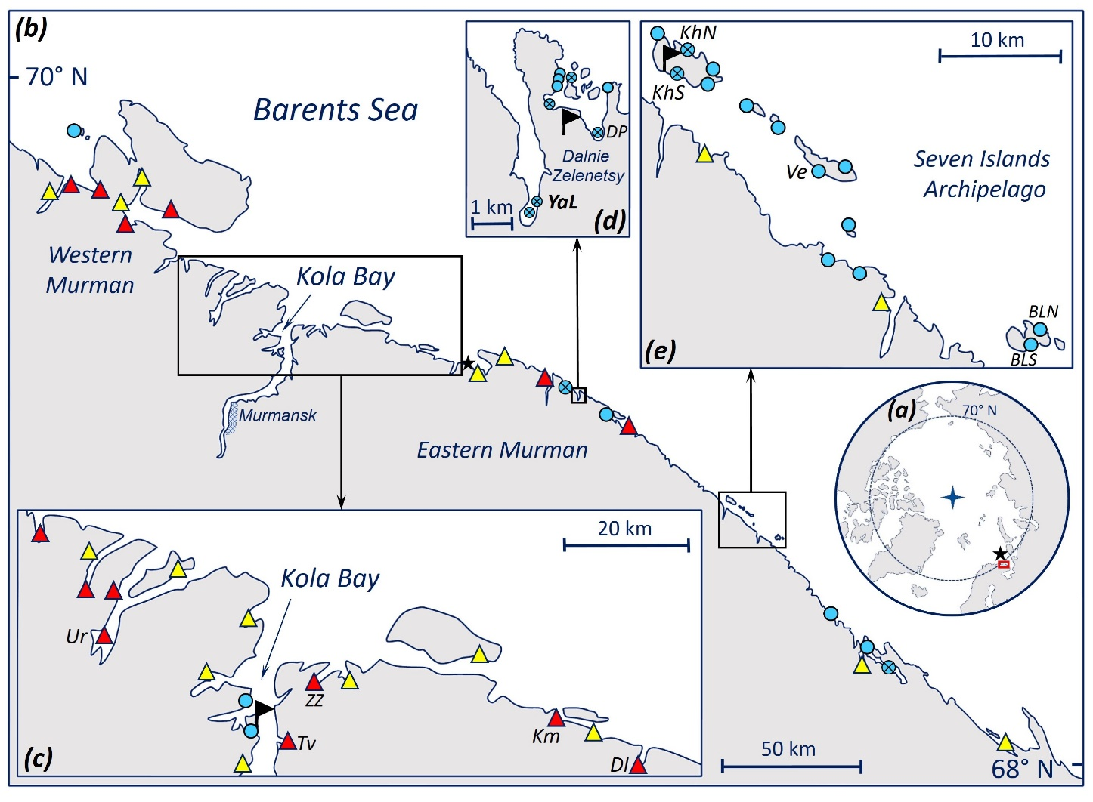

Figure 2.
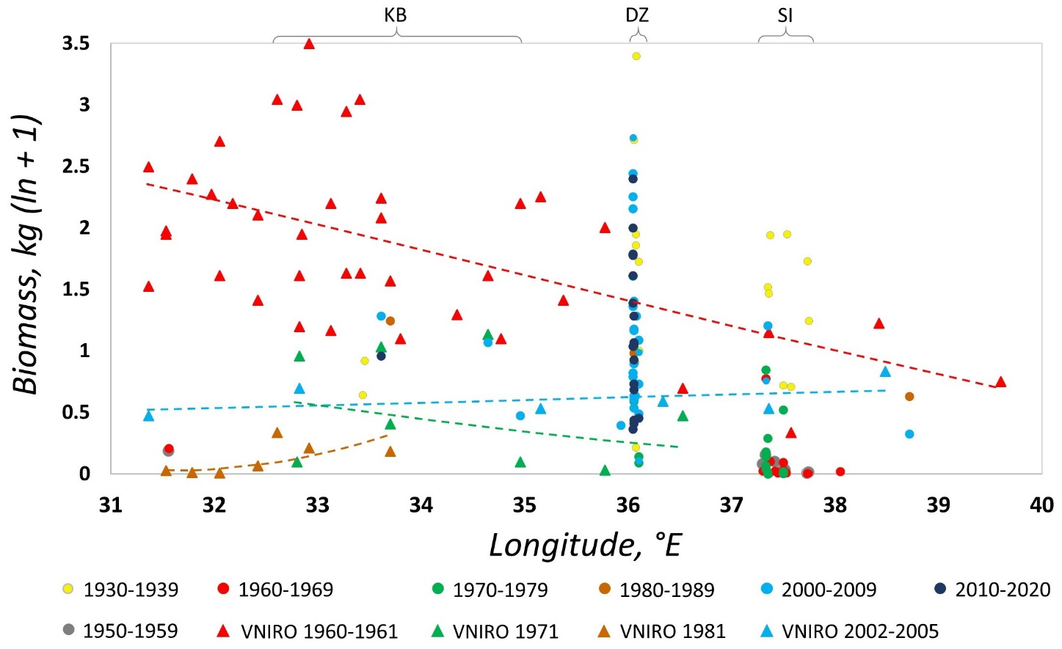

Figure 3.
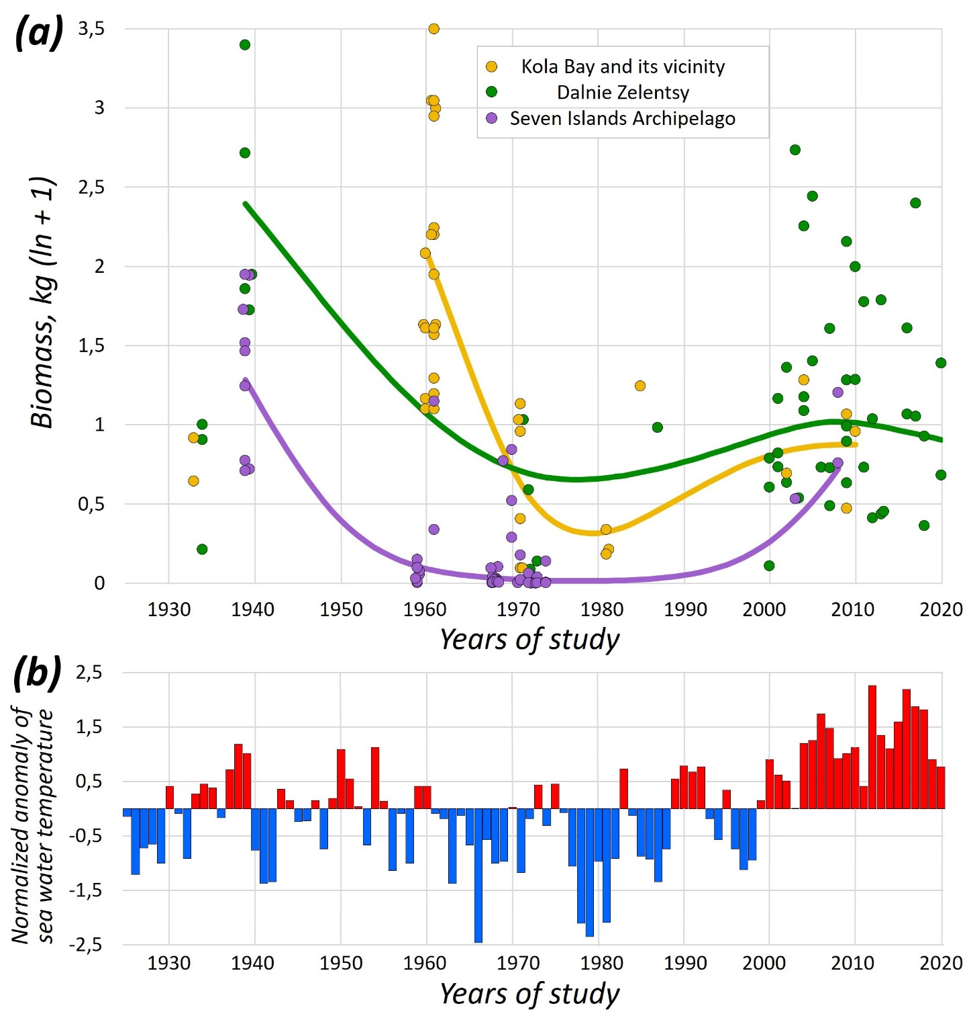

Figure 4.
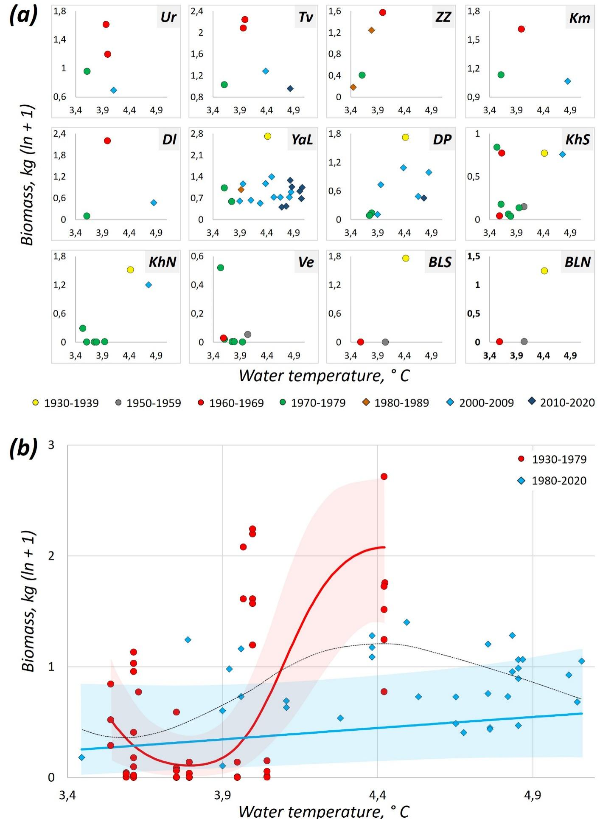

Figure 5.
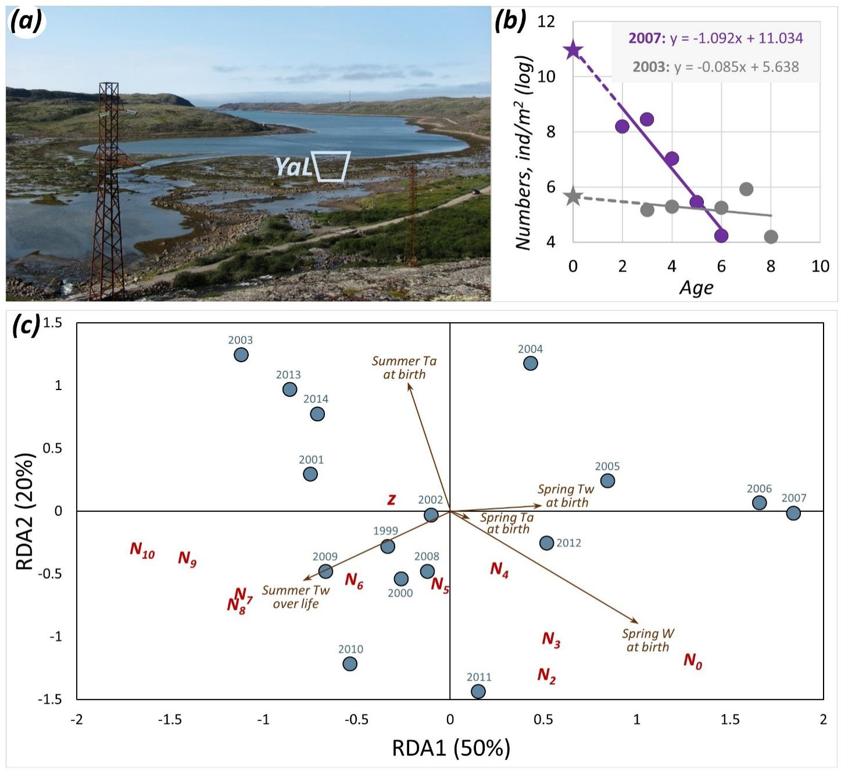

Table and Figure captions
Table 1. Structure of the data on the abundance of Murman mussels in 1933-2020. For each time period (decade), the number of observations at different sites in different years and, after the slash, the number of study sites at the entire Murman Coast and at each of the three best studied areas are given in the top rows. Study sites are shown in Fig. 1. Three best studied areas are the outer Kola Bay and its vicinity (KB), Dalnie Zelentsy (DZ) and the Seven Islands Archipelago (SI). Since some sites were studied repeatedly within the same decade, the number of observations usually exceeds the number of sites. Our data (in parentheses) and published data are shown separately. Mean biomasses ± Standard Errors of means for corresponding sets of observations are given in the bottom rows. References to published data are provided.
Figure 1. Sites of mussel surveys on the Murman Coast in 1933-2020. (А) Arctic. The location of the Murman Coast is indicated by the box. The star indicates stations 3-7 of the Kola Section, the temperature data from which were used in this study. (B) Murman Coast, areas of the most intensive mussel studies are indicated by boxes (C-E). The star shows the position of the weather station WMO no. 22028, the data from which were used in this study. (C) Outer Kola Bay and its vicinity. (D) Dalnie Zelentsy area. (E) Seven Islands Archipelago area. Flags in C-E denote research stations. Coloured symbols in B-E mark the sites of mussel surveys. Triangles mark the sites of VNIRO surveys made in 1960-1961 (Romanova et al., 1961, red and yellow filling) and in 1971 and 1981 (Antipova et al., 1984, yellow filling). All the sites surveyed in 1971 and 1981 were also investigated in the 1960s. Circles with crosses indicate our study sites. Monitoring sites where mussels were studied in at least three different decades are marked with their abbreviated names.
Figure 2. Distribution of mussel biomass along the Murman Coast in different decades. The colours of the symbols indicate estimates obtained in different time periods, triangles show data from VNIRO surveys and dots show data from other studies (see legend). Lines are GAM predictions (after backward Box-Cox transformation) fitted to VNIRO data from different surveys (Model 1). The position of the best studied areas, labelled as in Table 1, are indicated in the top of the figure.
Figure 3. Long-term changes of the biomass of littoral mussels at the three best studied areas of the Murman Coast and of annual water temperature in the Barents Sea. (A) Biomass, log kg/m². Dots - empirical estimates, lines - GAMM predictions (after backward Box-Cox transformation) for the entire period from 1939 to 2020 (Model 2). Data from different areas are shown by different colours (see legend). (B) Normalized anomalies of annual water temperature relative to the average of 4.15 °C in 1925-2020 at 0-200 m depth at stations 3-7 of the Kola Section according to Bochkov, 2005 and Karsakov et al., 2022.
Figure 4. Relationship between mussel biomass in the monitoring populations in different years and water temperature. Temperature at 0-200 m depth at stations 3-7 of the Kola Section averaged over five years preceding the year of the mussel survey is used. (A) Primary data. Abbreviated site names are as in Fig. 1 and Table S3. Estimates from different decades are shown by different colours (see legend). (B) Predictions of regression models. Dots are all biomass estimates in monitoring sites. Solid lines are GAMM predictions (after backward Box-Cox transformation) fitted to data from different periods (see legend) (Model 3). Black dashed line is LOESS approximation of all the data.
Figure 5. Influence of environmental factors on the abundances of mussels of different generations in YaL population in 1999-2020. (A) Panorama of the top of Yarnyshnaya Inlet at low tide. The photo was taken from the southern shore in 2013. The study site (YaL) is marked with a trapezium. Width of the mussel-inhabited littoral zone is 150 m. (B) Two contrasting survivorship curves for generations of 2003 and 2005. Dots are numbers, lines are regressions. Stars label N₀. Equations of linear models (y = z*x + N₀) are given. (C) Redundancy analysis (RDA) ordination plot showing the relationship between generations characterized by demographic parameters (N₀, z, numbers in different years throughout the lifetime) and environmental constraints selected by BIO-ENV as best explaining the variation between generations (see the text). Points represent generations (years of birth are indicated). Text markers represent demographic parameters. Arrows indicate environmental constraints. Ta and Tw stand for air and water temperature, respectively, W stands for wind speed.

